**Control Arm Operational Experiment**

The Control Arm is a feedback control module that allows students to explore and see controls in action. A beam is mounted to a pivot on a rotator, with hard stops to restrict its motion. The rotator is mounted on a fixed base. Two types of arms are tested in the experiment: a rigid arm manufactured from 5052 Aluminum and a stainless steel flexible arm instrumented with strain gauges to measure the deflection of the tip. A potentiometer measures the rotational position of the rotating shaft. A small DC motor controls the torque applied to the base of the flexible arm.

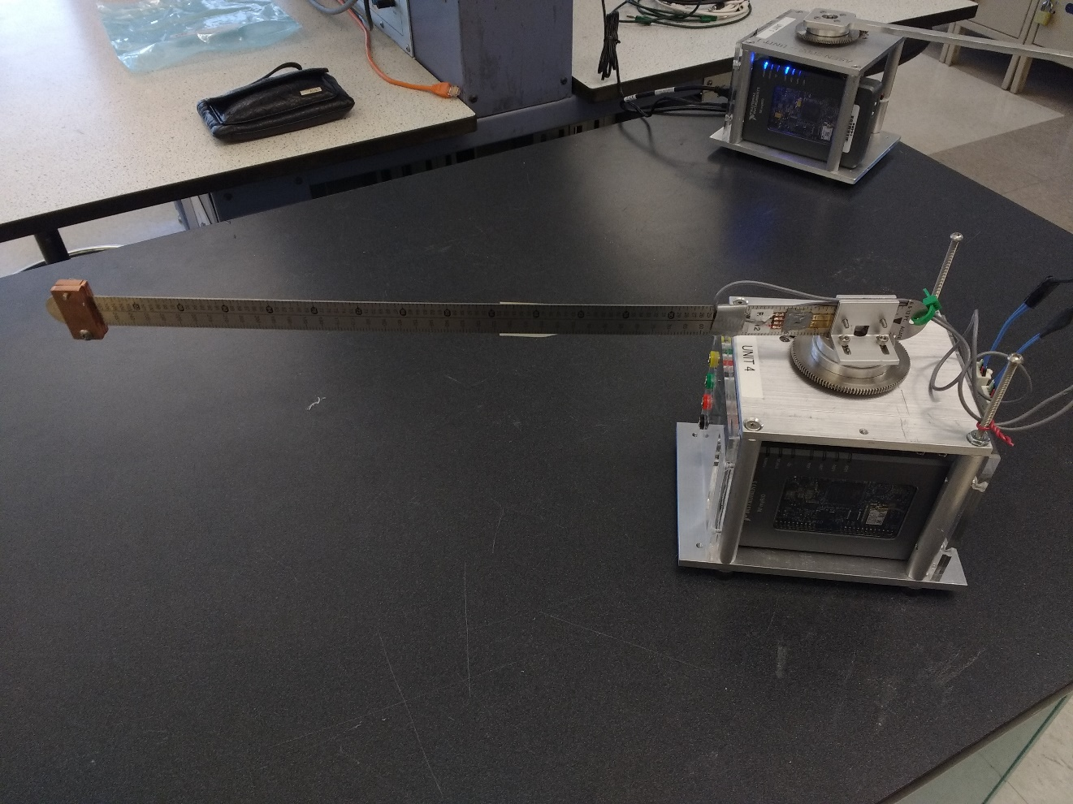

Strain Gauge

Flexible Arm

Figure : Flexible Arm Module

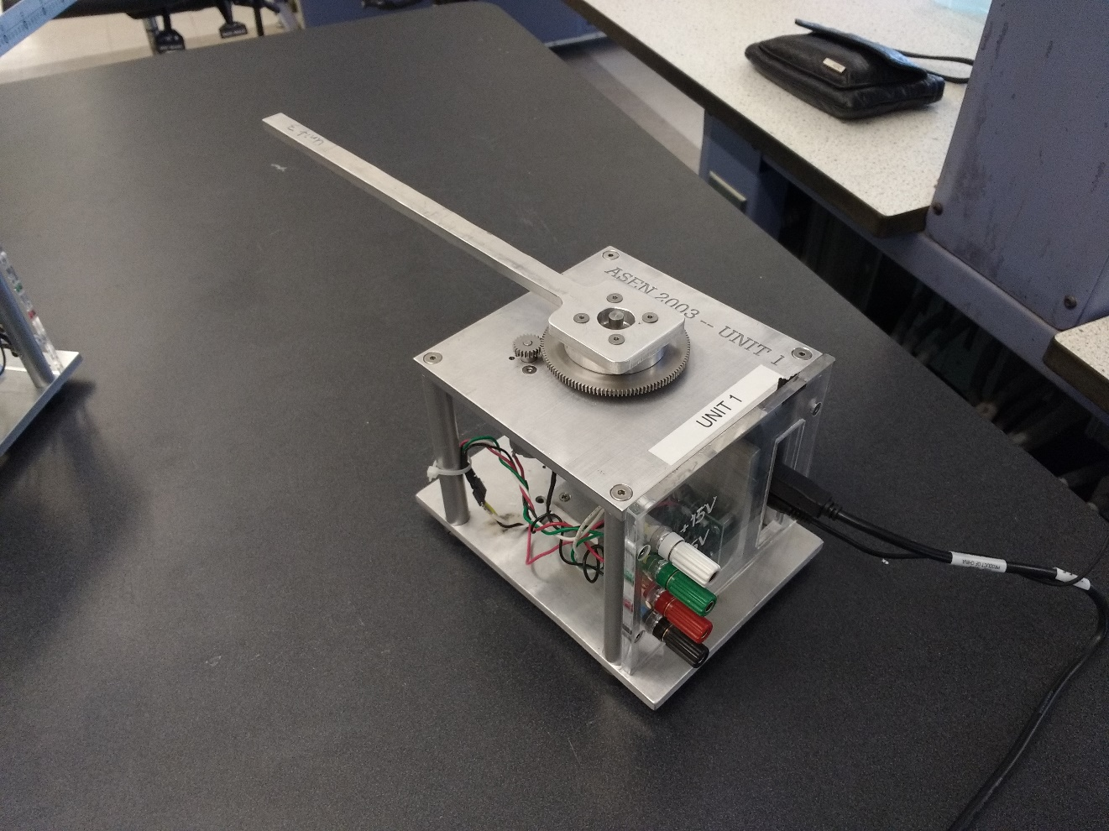

Rigid Arm

Figure : Rigid Arm Module

**Set-up Procedure:**

1. Clamp the Rotary Control Arm box to the lab cart. Check the full range of motion of the arm to ensure that the area is clear.
2. Connect the +15V (white/yellow), -15V (green), 5V (red), and GND (black) to the power box on the lab station. BE CAREFUL WITH CABLE COLORS AND MATCH VOLTAGE LEVELS! (See Figure 3 below).

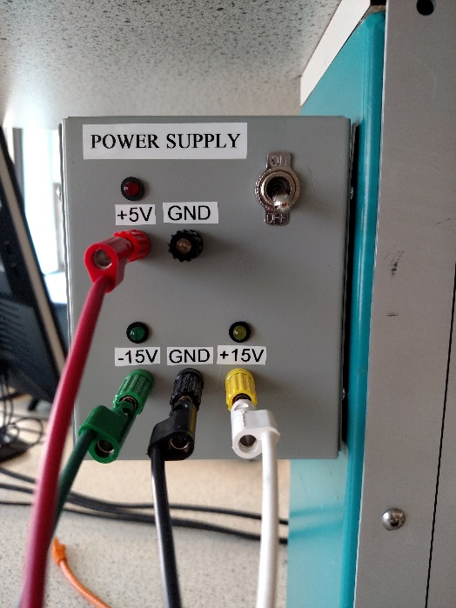

Figure : Lab Station Power Supply Box

1. Connect the myRIO power supply to a standard wall outlet.
2. Connect the myRIO USB to the lab station computer.
3. Turn the power box ON.

**Operational Procedure:**

1. Select and open the **Host** **Main PID.Shortcut** in the ASEN 2003 course folder for the rotary arm lab. Click the run button in the top left of this VI, it then will communicate directly with the program running on the myRIO. See Figure 4 below.

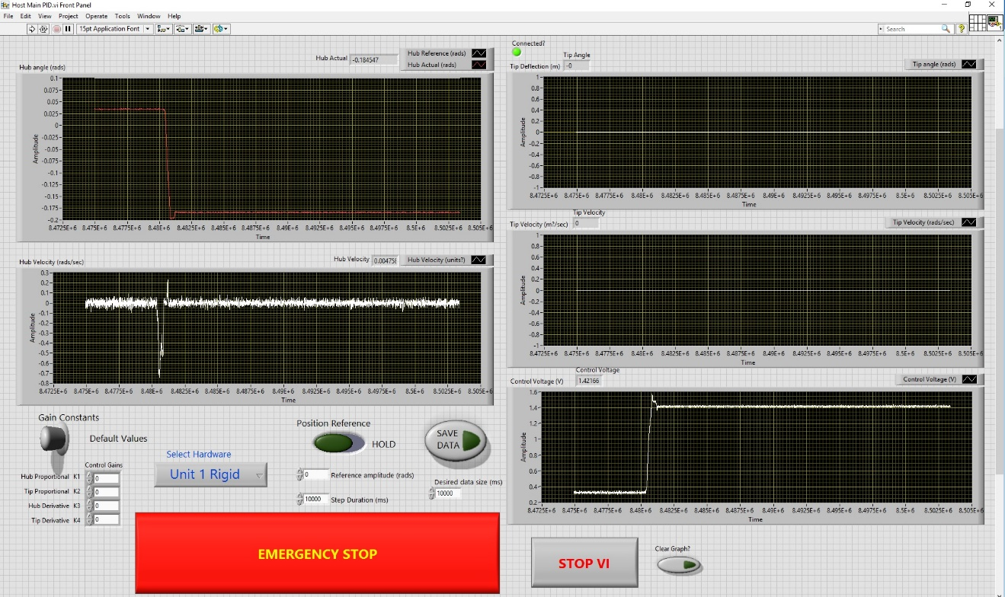

Figure : Control Arm LabVIEW VI

1. Select the correct unit # from the pulldown menu on the VI.
2. Select the “Clear Graph” button to initialize the graphs.
3. You are now ready to control the arms. **The motor control power can be cut at any time with the “Emergency Stop” button on the VI or the Esc key.**

**Flexible Arm:**

1. The VI defaults to a flexible arm setup with default control gains. The arm will initially attempt to keep its position at 0 radians.
2. Try moving the arm gently with your hand and notice the behavior
3. Change the Position Reference slider so that it reads STEP and change the Reference/Amplitude to 0.1 rad and the Step Duration to 10 seconds. The control input for the position is now set to a step function of amplitude 0.1 rad and frequency of 0.1 Hz.
4. Switch the *Gain Constants* button from *Default Values* to *Enter Values* to enables custom control gains. **MAKE SURE TO USE THE CORRECT UNITS!**
   1. K1 is the proportional gain applied to the hub’s angle measurement () from the reference. Units are V/rad.
   2. K2 is the gain applied to the tip sensor displacement (d). Units are V/m.
   3. K3 is the gain applied to the hub’s angular rate (). Units are V/(rad/s).
   4. K4 is the gain applied to the tip’s displacement rate (). Units are V/(m/s).

**Note: Stable gains are K1, K3, K4 positive while K2 is negative.

1. Enter or use the default time window (in seconds) in the *Desired* data size field. This sets the buffer size for data capture. BE SURE to allow the *Desired* time to pass on the screen to be sure the data looks good, then click the *Capture Data* button. This saves the PREVIOUS time window of data that has already passed, which is different that the VI used on the wind tunnel. DON’T MAKE ANY CHANGES TO THE VI DURING THIS TIME OR YOUR DATA WILL BE CORRUPTED.

**Rigid Arm:**

1. The VI defaults to a flexible arm setup with default control gains. Click the *Select Hardware* switch to select the **Rigid Arm**. The arm will initially attempt to keep its position at 0 radians.
2. Try moving the arm gently with your hand and notice the behavior.
3. Change the *Position Reference* slider so that it reads *STEP* and change the *Reference/Amplitude* to 0.1 rad and set the *Step Duration* to 10 seconds. The control input for the position is now set to a step function of amplitude 0.1 rad and frequency of 0.1 Hz.
4. Switching the *Gain Constants* button from *Default Values* to *Enter Values* to enables custom control gains. **MAKE SURE TO USE THE CORRECT UNITS!**
   1. K1 is the gain applied to the hub angle measurement (). Units are V/rad.
   2. K2 is N/A **because THE TIP OF THE RIGID ARM DOESN’T DISPLACE, IT’S RIGID.**
   3. K3 is the gain applied to the hub angle rate (). Units are V/(rad/s).
   4. K4 is N/A.
5. Enter or use the default time window (in seconds) in the *Desired* data size field. This sets the buffer size for data capture. BE SURE to allow the *Desired* time to pass on the screen to be sure the data looks good, then click the *Capture Data* button. This saves the PREVIOUS time window of data that has already passed, which is different that the VI used on the wind tunnel. DON’T MAKE ANY CHANGES TO THE VI DURING THIS TIME OR YOUR DATA WILL BE CORRUPTED.

Last Updated: 4/12/17